GT Excel Assignment:

1. Given the provided data, what are three conclusions we can draw about Kickstarter campaigns?
   1. There are exponentially greater submissions for Theater than any other category – specifically in plays.   
      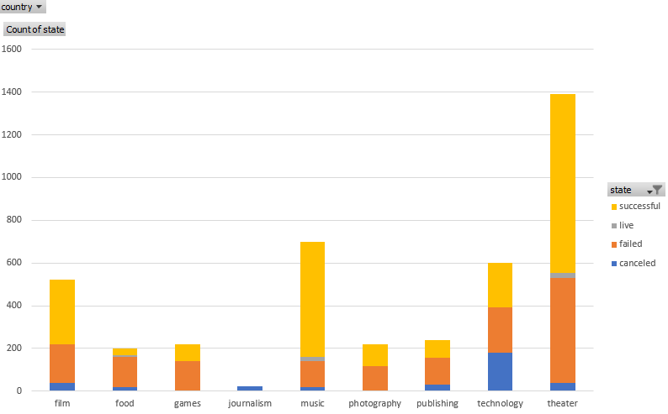
   2. Raw data points to the highest success number to be in theater; however, a closer look (suggestions in Q3) reveals 60% of submissions are successful, whereas – music has a 77% success rate.   
      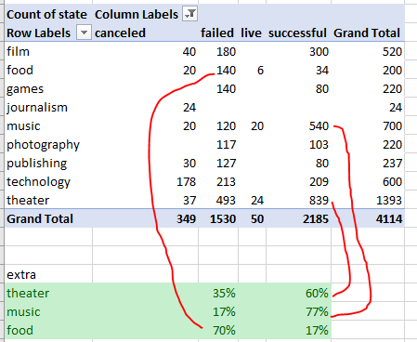
   3. Data suggest that submissions (success, failed, and canceled) are cyclical in nature. Starting the highest in the start of the year and steadily declining towards the end of the year. Successful submissions show this trend the most dramatic.   
      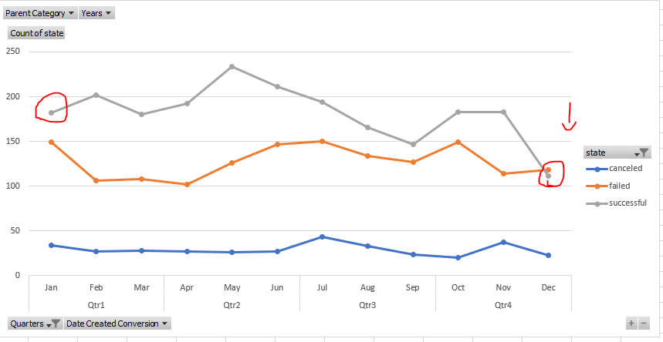
2. What are some limitations of this dataset?
   1. Data set only looks at Kickstarter and no other data set… i.e. – tech startup data would best be served using “tech crunch” data.
   2. Data set is missing data on how well prepared a pitched concept is…be it years of experience in the field, educational background, etc. which might be a leading indicator on how likely/prepared a project’s outcome would be
3. What are some other possible tables and/or graphs that we could create?
   1. We could have used a pivot table to see success, failed percentage by category to get a better understanding of where one should focus efforts and not focus efforts
   2. We could use a pivot chart to depict the above table
   3. We can also do a standard deviation by category